En esta práctica vamos a montar un entorno de despliegue de aplicaciones modernas utilizando contenedores Docker.
Despliegue de Aplicaciones con Docker
Actividad 1.6
Cristóbal Suárez Abad
Administración de Sistemas Operativos
2º ASIR
Contenido
Instalación de Docker Compose. 2
1. Despliegue de Ruby on Rails 2
2. Despliegue de Prestashop. 5
3. Despliegue de WordPress. 7
4. Despliegue de Moodle: 9

Instalación de Docker Compose.
sudo apt-get update
sudo apt-get install docker-compose-plugin
Comprobamos version: docker compose version

1. Despliegue de Ruby on Rails
Crea un directorio a parte donde albegar el .yaml del docker compose. Dentro de ese directorio crea otro directorio llamado “myapps”.
mkdir -p /home/usuario/docker_compose/RubyOnRails/myapp
cd /home/usuario/docker_compose/RubyOnRails
- Genera un proyecto Rails dentro del contenedor:
docker run --rm -v $(pwd)/myapp:/app -w /app ruby:3.3 bash -c "gem install rails && rails new . --database=mysql"
- Edita myapp/config/database.yml y cambia la parte de development así:
development:
adapter: mysql2
encoding: utf8
database: myapp_development
username: rails
password: rails
host: mariadb

- docker-compose.yaml
services:
mariadb:
image: mariadb:latest
container_name: mariadb
environment:
- MARIADB_ROOT_PASSWORD=root
- MARIADB_DATABASE=myapp_development
- MARIADB_USER=rails
- MARIADB_PASSWORD=rails
volumes:
- mariadb_data:/var/lib/mysql
networks:
- railsnet

myapp:
image: ruby:3.3
container_name: myapp
ports:
- "8001:3000"
depends_on:
- mariadb
working_dir: /app
volumes:
- ./myapp:/app
command: bash -c "bundle install && rails server -b 0.0.0.0"
networks:
- railsnet

volumes:
mariadb_data:

networks:
railsnet:
driver: bridge

- Arranca: docker compose up -d
- http://10.2.17.10:8001/
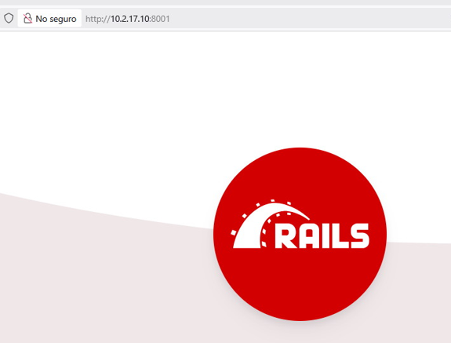

2. Despliegue de Prestashop.

Usamos la guía:
https://devdocs.prestashop-project.org/9/basics/installation/environments/docker/

Creamos directorio:
mkdir -p /home/usuario/docker_compose/Prestashop
cd /home/usuario/docker_compose/Prestashop

- docker-compose.yaml
services:
mariadb:
image: mariadb:latest
container_name: mariadb-prestashop
environment:
- MARIADB_ROOT_PASSWORD=root
- MARIADB_DATABASE=mitienda
- MARIADB_USER=pepe
- MARIADB_PASSWORD=pepe
volumes:
- mariadb_data:/var/lib/mysql
networks:
- prestashopnet

prestashop:
image: prestashop/prestashop:latest
container_name: prestashop
depends_on:
- mariadb
ports:
- "8080:80"
- "8443:443"
environment:
- PRESTASHOP_HOST=127.0.0.1
- PRESTASHOP_DATABASE_HOST=mariadb
- PRESTASHOP_DATABASE_PORT_NUMBER=3306
- PRESTASHOP_DATABASE_NAME=mitienda
- PRESTASHOP_DATABASE_USER=pepe
- PRESTASHOP_DATABASE_PASSWORD=pepe
- PRESTASHOP_FIRST_NAME=Cristobal
- PRESTASHOP_LAST_NAME=Suarez
- PRESTASHOP_PASSWORD=admin123
- PRESTASHOP_EMAIL=admin@mitienda.local
volumes:
- prestashop_data:/bitnami/prestashop
networks:
- prestashopnet

volumes:
mariadb_data:
prestashop_data:

networks:
prestashopnet:
driver: bridge

- Arranca: docker compose up -d
- http://10.2.17.10:8080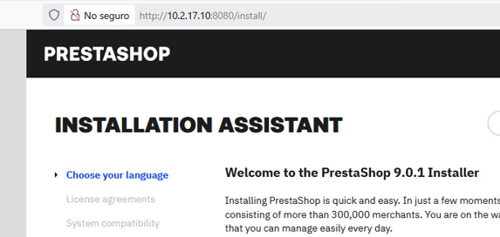

3. Despliegue de WordPress.

Seguimos la guía:
https://aulasoftwarelibre.github.io/taller-de-docker/docker-compose/#creacion-de-contenedores-automatizada

- Creamos su propio directorio con “mkdir”.
- compose-docker-yaml
services:
db:
image: mariadb:latest
volumes:
- mariadb_wp_data:/var/lib/mysql
environment:
- MYSQL_ROOT_PASSWORD=12345
- MYSQL_DATABASE=wordpress
- MYSQL_USER=cristobal
- MYSQL_PASSWORD=12345
networks:
- wordpress

web:
image: wordpress:latest
depends_on:
- db
volumes:
- wp_data:/var/www/html
environment:
- WORDPRESS_DB_USER=cristobal
- WORDPRESS_DB_PASSWORD=12345
- WORDPRESS_DB_HOST=db
- WORDPRESS_DB_NAME=wordpress
ports:
- "8082:80"
networks:
- wordpress

volumes:
mariadb_wp_data:
wp_data:

networks:
wordpress:

- Arranca: docker compose up -d
- http://10.2.17.10:8082

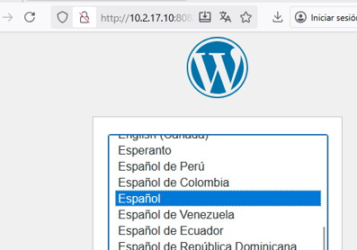

4. Despliegue de Moodle:

- Creamos su propio directorio:
- Dentro de ese directorio nos bajamos los ficheros de Moodle en una carpeta propia:

git clone -b MOODLE_404_STABLE git://git.moodle.org/moodle.git ./moodle-code
sudo chown -R 33:33 ./moodle-code

- Creamos otro directorio para la carpeta “moodledata_local” que irá dentro del contenedor:

mkdir moodledata_local
sudo chown -R 33:33 moodledata_local

- docker-compose.yaml
services:
mariadb:
# ... (Sin cambios)
image: mariadb:latest
container_name: mariadb-moodle
restart: always
environment:
MYSQL_ROOT_PASSWORD: rootpass
MYSQL_DATABASE: moodle
MYSQL_USER: cristobal
MYSQL_PASSWORD: 12345
volumes:
- mariadb_data:/var/lib/mysql
networks:
- moodle_network

moodle:
image: moodlehq/moodle-php-apache:8.4
container_name: moodle
restart: always
depends_on:
- mariadb
ports:
- "8083:80" # HTTP
- "8444:443" # HTTPS
environment:
MOODLE_DATABASE_TYPE: mysqli
MOODLE_DATABASE_HOST: mariadb
MOODLE_DATABASE_NAME: moodle
MOODLE_DATABASE_USER: cristobal
MOODLE_DATABASE_PASSWORD: 12345
MOODLE_USERNAME: cristobal
MOODLE_PASSWORD: 12345
MOODLE_SITE_NAME: "Moodle SUAREZ1"
MOODLE_EMAIL: admin@suarez1.abad2
volumes:
- ./moodle-code:/var/www/html
- ./moodledata_local:/var/www/moodledata # <-- Mapeo a carpeta local
networks:
- moodle_network

volumes:
mariadb_data:
# Eliminados moodle_data y moodle_mariadb_data

networks:
moodle_network:

- Arranca: docker compose up -d
- http://10.2.17.10:8083/install.php
